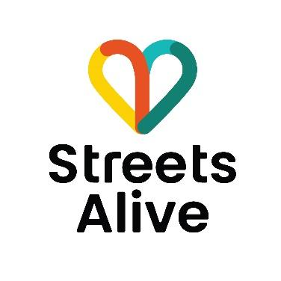
Draft Application Form
Stream1 - Up to $5,000 inc GST

Before you get started, please confirm you have you read the documents:
- Streets Alive Eligibility & Guidelines
- Funding objectives
- Eligibility criteria
- Resources https://streetsalive.org.au/resources/

FUNDING APPLICATION
Applicant name:
Applicant role:
Applicant phone number:
Applicant email:
Organisation name:
Address:
Website or social media (optional):
Select organisation type: | - Town Team  - Community Group  - School P&C or P&F  - Community Resource Centre (CRC)  - Local Government  - Other, please specify
ABN or AIRN (if applicable)
Is this organisation unincorporated: | - Yes  - No

AUSPICE REQUIREMENTS
Only answer this section if your organisation is unincorporated and/or does not have an ABN or AIRN.
If your organisation is not incorporated or have an ABN or AIRN, you are required to nominate an auspice organisation to administer the funding on your behalf.
Please note:
- This auspice organisation must have an ABN or AIRN.
- Individual/Sole Traders are ineligible to auspice.
- Please ensure your nominated auspice organisation has agreed to support your application prior to applying for funds.
- If your application is successful, your auspice organisation will be included and required to sign the funding agreement.
Auspice organisation name:
Contact name:
Email address:
Phone number:
ABN:
Address:

PROJECT TEAM
Please tell us who is involved in the delivery of your project? (e.g. team members, volunteers, project partners etc.)
Name | Role | Notes

How many events or projects has your organisation or project team delivered in the past?
  - 0-5
  - 6-10
  - 11-20
  - 21+

Please provide an example of a project or initiative that your organisation has previously delivered. Where this is your organisation’s first project, you can demonstrate the experience of the group by including examples of relevant projects your team members have previously delivered.

PROJECT INFORMATION
Project name:
Project town/suburb:
Region
Please describe the location that this project relates to, e.g. street(s), roads(s), path(s) or intersection(s). You can include a link or upload photos, map, drawing etc below)

- Tell us about the road safety issue(s) your community is facing and types or people or users who are impacted? Note: People or users may include residents, school children, business owners, drivers, pedestrians, cyclists, mobility scooters.

- Please select the objective(s) your project aims to achieve? You may select more than one.

  - To build capability and capacity of local communities to deliver traffic calming and road safety initiatives in local streets and neighbourhoods
  - To change attitudes and behaviours around speed to emphasise streets for people over cars
  - To improve safety of our town centres and make them more vibrant and people friendly

- Please describe your project idea:

- Please select what type of project you intend to deliver. You may select more than one.

- Implement or trial a street calming solution(s) (e.g. planter boxes, street trees, street furniture, signage, speed bumps etc)
- Community event or workshop
- Conduct research and gather insights into local attitudes, behaviours and street improvements
- Develop project plan for a larger funding request
- Build the capability and capacity of my community and/or community group
- Other, please specify

- Estimated project start date:
- Estimated project completion date:

- Please provide an overview of your project timeline. What steps will you take to deliver this project?

Item or milestone | Date | Description
Project completion
Submit Acquittal Report

- How will you communicate your project to your community and/or local stakeholders?

- Have you discussed your project idea with your Local Government
- Yes
- No
- Not applicable

- Do you think your project will require approvals from other stakeholders? (Local Government, land owners, residents, business owners etc)
  - Yes
  - No
  - Unsure
  - If yes, please specify
- If your project is funded, does your organisation agree to acquire the required insurances to deliver the project?
  - Yes
  - No

BUDGET
Please outline the estimated costs associated with your project:

Item | Cost | Notes
Total cost: | $

Note, these costs can include external consultant fees, artists fees, hire equipment, education, permits, insurance, marketing, printing and supplies costs.

SUPPORTING DOCUMENTATION (optional)
You can upload up to 4 supporting documents to assist us with the assessment of your application. This may include a letter of support, referee details, images, maps etc
Application complete.

